Day 2 – 17th May 2025 - 113195064 – Bondili Bhavya Charitha

**TASK – 1: Create a Repository - DONE**

**TASK – 2: Add a file to a repository using GUI - DONE**

**TASK – 3: Create a folder in your VM and create a test file 1 and 2 and try to push file 1 to repo.**

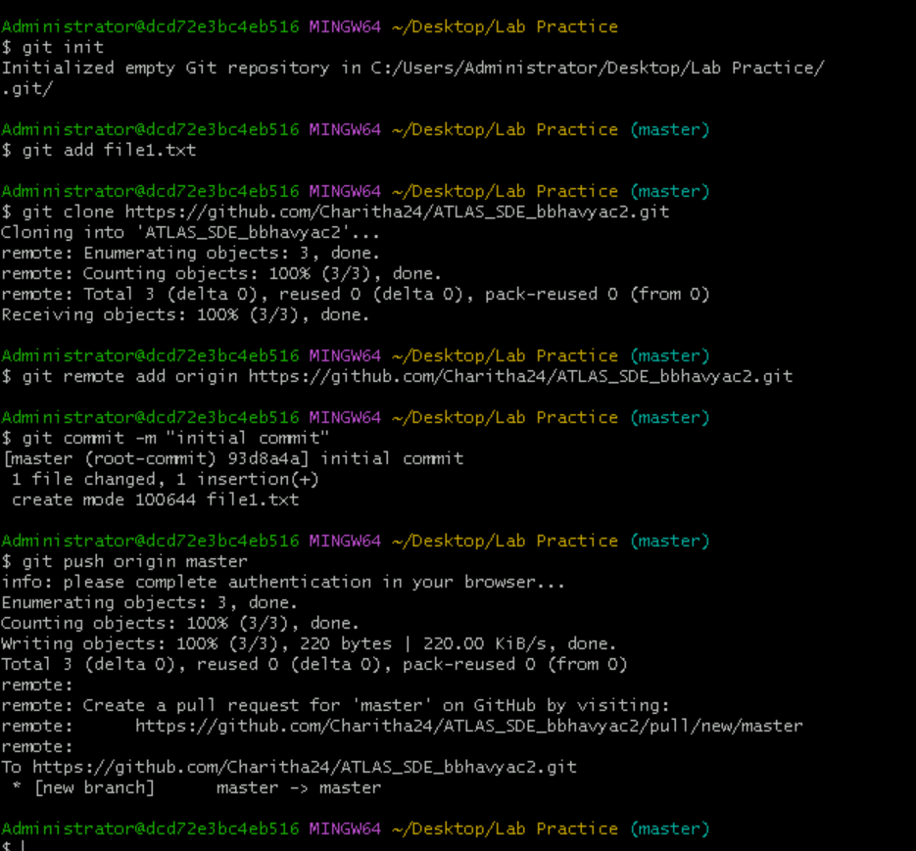

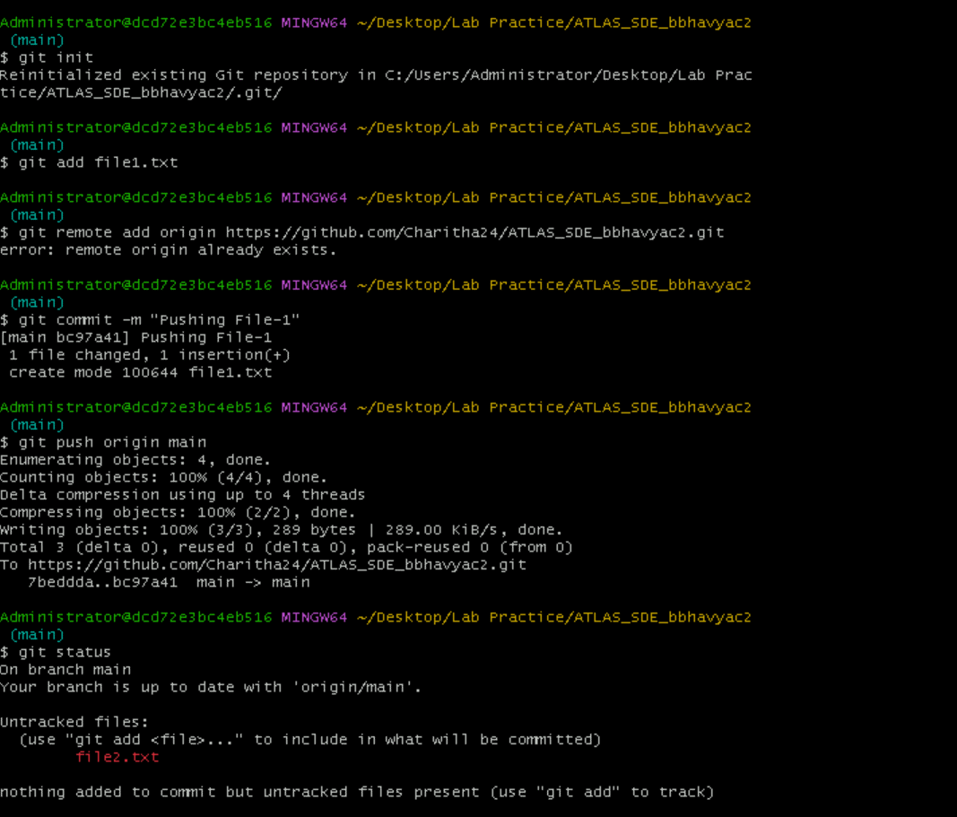

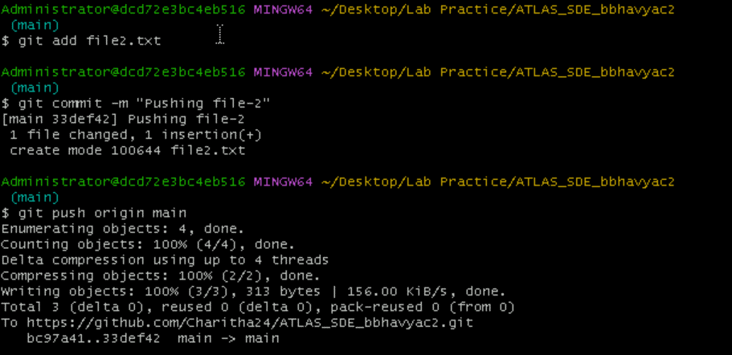

**TASK: 4 – Implementing GIT Commands**

**Branching and checking out to new branch**

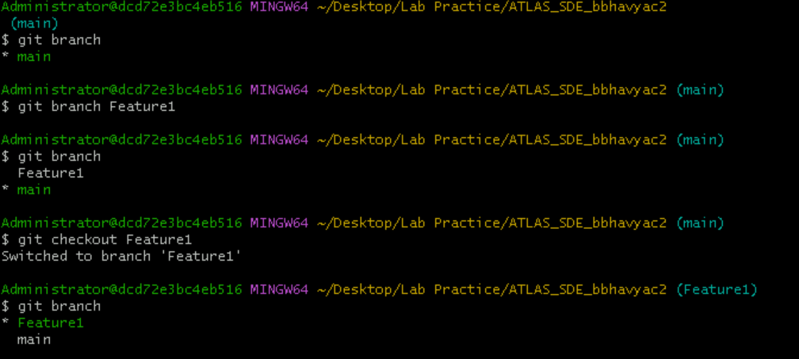

**Creating a new text file and pushing it to the branch**

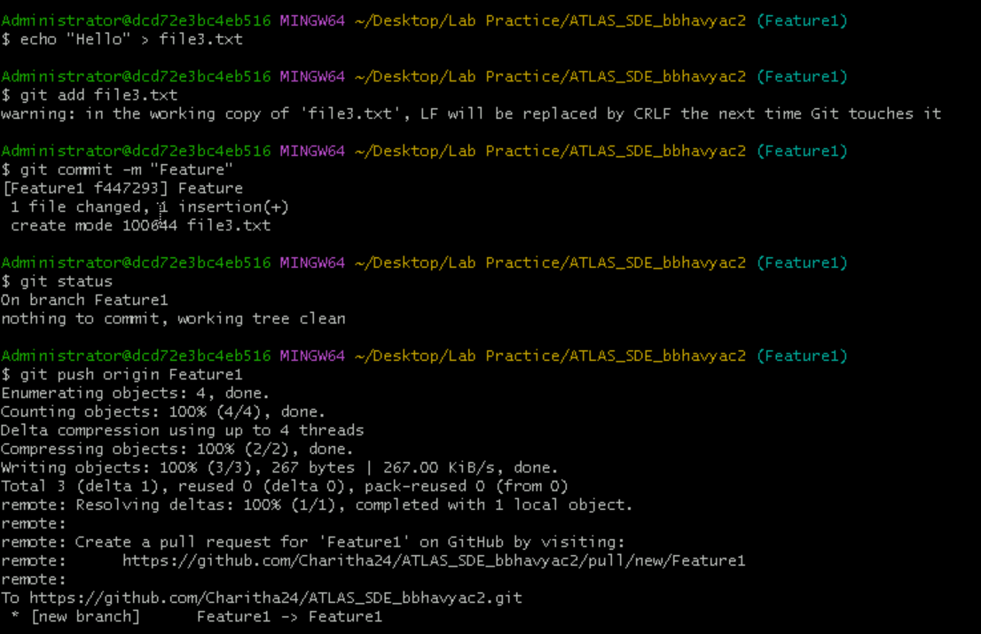

**Stash Command**

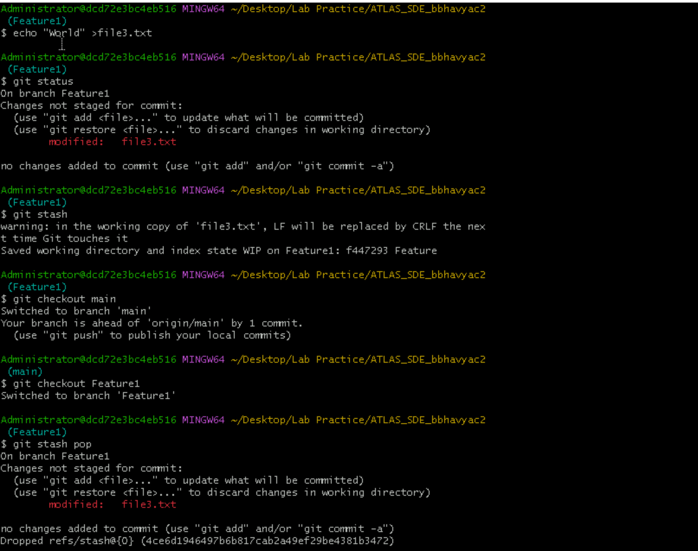

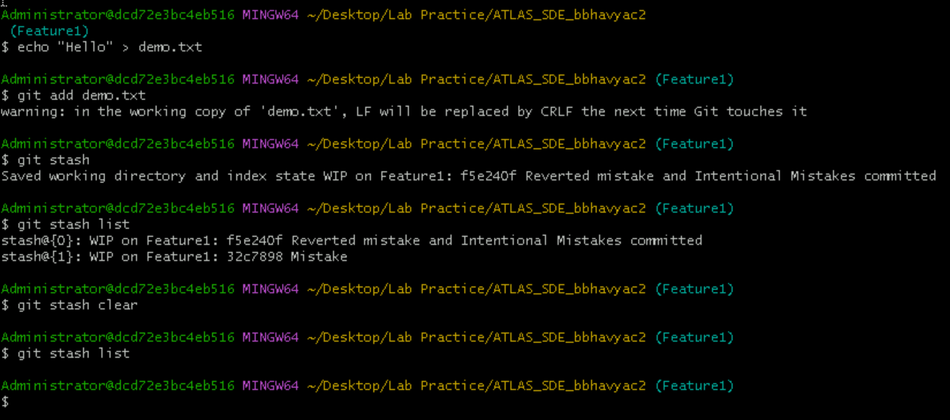

**Reverting the Commit**

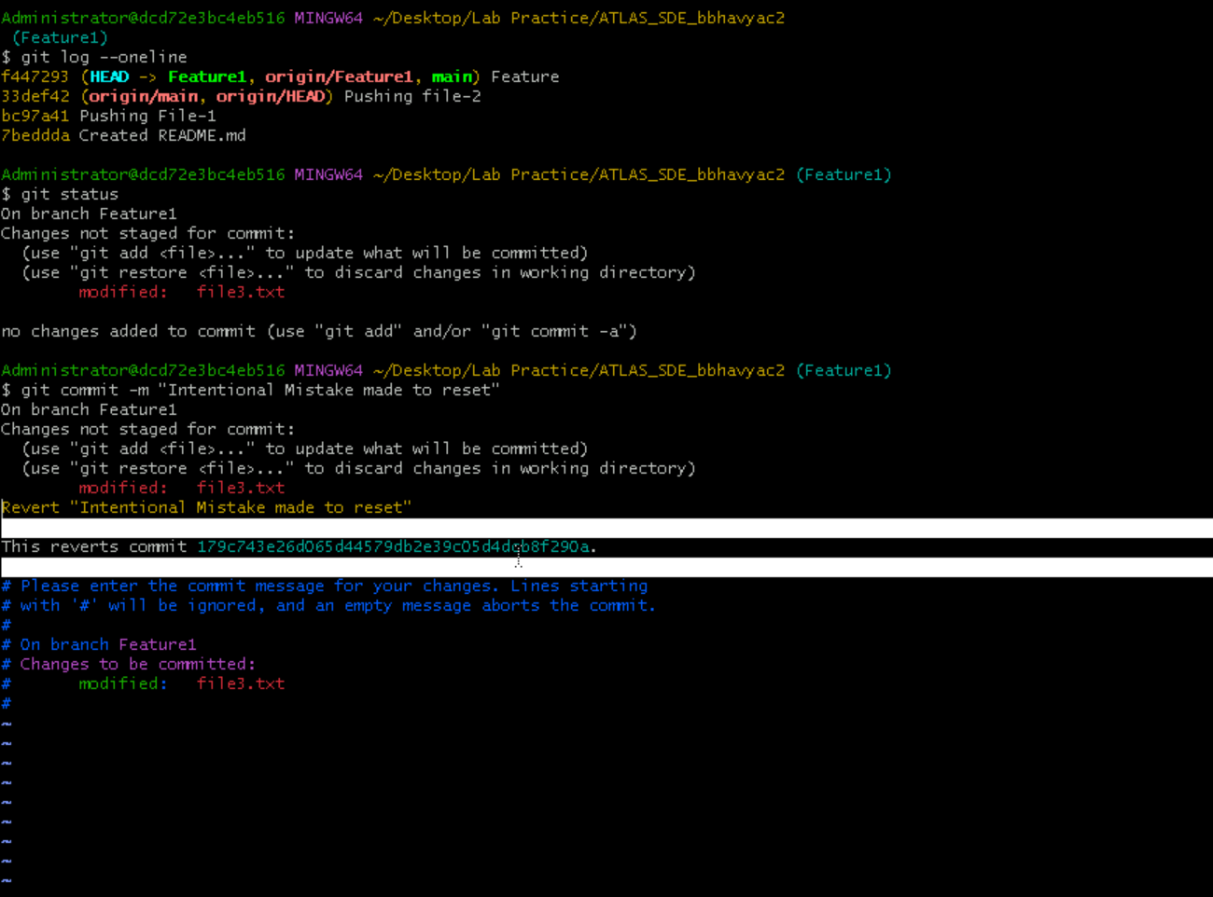

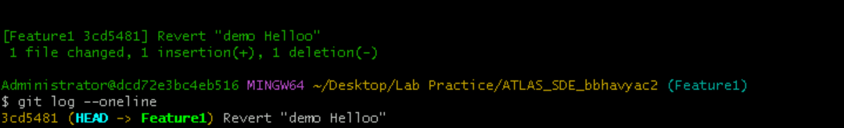

**RESET:**

I had the file file3.txt with text “Hello” initially then I modified file with text “World”. After giving git reset command, it reset to “Hello” text.



**SHOW:**

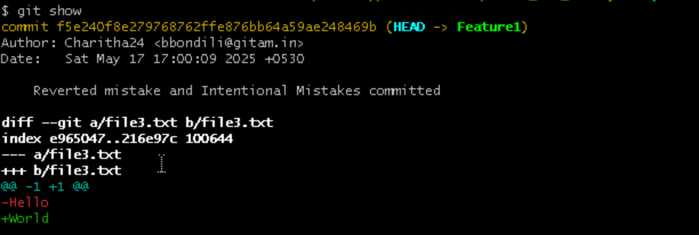

**TAG:**

